Unit 1 FR Progress Check
- Assume gadgets are sold in a competitive market, the equilibrium price is $6, and the equilibrium quantity is 500 units.
(a) Using the numerical values above, draw a correctly labeled graph of the market for gadgets and show each of the following.
(i) The equilibrium price (ii) The equilibrium quantity
(b) At a price of $8 per unit, will there be a surplus or a shortage in the market? Explain.
(c) Assume gadgets now become more popular. On your graph in part (a), show the effect of the increase in gadgets' popularity on the equilibrium price and quantity of gadgets.
(d) Assume instead there is an increase in the price of tin, a major input in producing gadgets. What will be the effect of an increase in the price of tin on the market for gadgets?
(e) If both changes in part (c) and part (d) occurred simultaneously, will the equilibrium quantity of gadgets increase, decrease, remain unchanged, or be indeterminate? Explain.
- Zeetopia and Freshland are two small tropical islands that use the same amounts of resources to produce mangoes and coconuts as shown in the table below
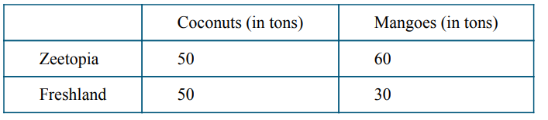
(a) Which island has an absolute advantage in producing coconuts? Explain.
(b) Which island has a comparative advantage in producing coconuts? Explain.
(c) Assume Zeetopia and Freshland decide to specialize according to their comparative advantages and 1 ton of coconuts is exchanged for 1 ton of mangoes. Are specialization and trade under these terms beneficial to both Zeetopia and Freshland? Explain.
(d) Assume the two islands experience constant opportunity costs in the production of the two products. Draw a correctly labeled graph illustrating Zeetopia’s and Freshland’s production possibilities, showing coconuts on the horizontal axis and mangoes on the vertical axis. Plot the numerical values from the table above on your graph.
(e) On your graph in part (d), show a combination of coconuts and mangoes, labeled as point X that is unattainable for Freshland but feasible and inefficient for Zeetopia.

Answers
a
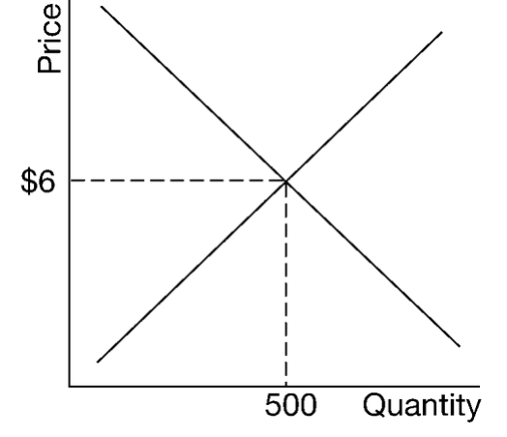
B The response states that there will be a surplus in the market at a price of $8 per unit and explains that at a price of $8, quantity supplied will be greater than quantity demanded.
C
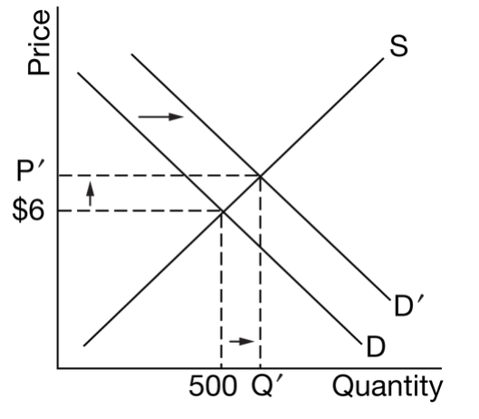

D The response states that the supply of gadgets will decrease or the supply curve will shift to the left.

E The response states that the equilibrium quantity will be indeterminate and explains that the change in the equilibrium quantity will depend on the magnitude of change in both the demand and the supply curves, since the curves shift in opposite directions.

2
A The response states that neither country has an absolute advantage in producing coconuts and explains that the two countries produce the same amount of coconuts (50 tons) using the same amount of resources

B The response states that Freshland has a comparative advantage in producing coconuts and explains that Freshland has a lower opportunity cost in producing mangoes than Zeetopia [Freshland’s opportunity cost of producing one ton of coconuts is 0.6 ton of mangoes ( ) , whereas Zeetopia’s opportunity cost of producing one ton of coconuts is 1.2 tons of mangoes ( ) ].

C The response states that yes, the terms of trade are mutually beneficial because they lie between the opportunity costs for both islands (0.6 and 1.2 tons of mangoes). [In order for the terms of trade to be beneficial to both parties, they must fall between the opportunity costs of the two countries (i.e., between 0.6 and 1.2 tons of mangoes).]
D
d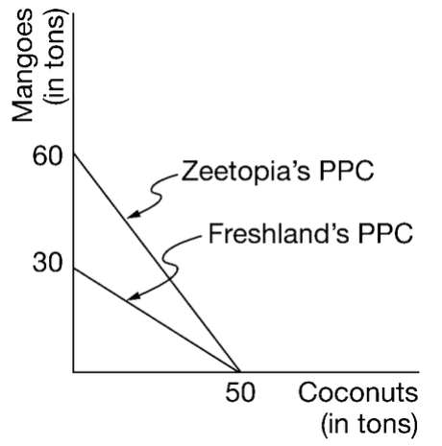
E
